Results From Normal Model
Output from WinBUGS. (For fun, compare to the JAGS output, especially the autocorrelation functions.)
I always want to look at the individual posteriors at least once when I first start fitting a model. For example:

Density plots.

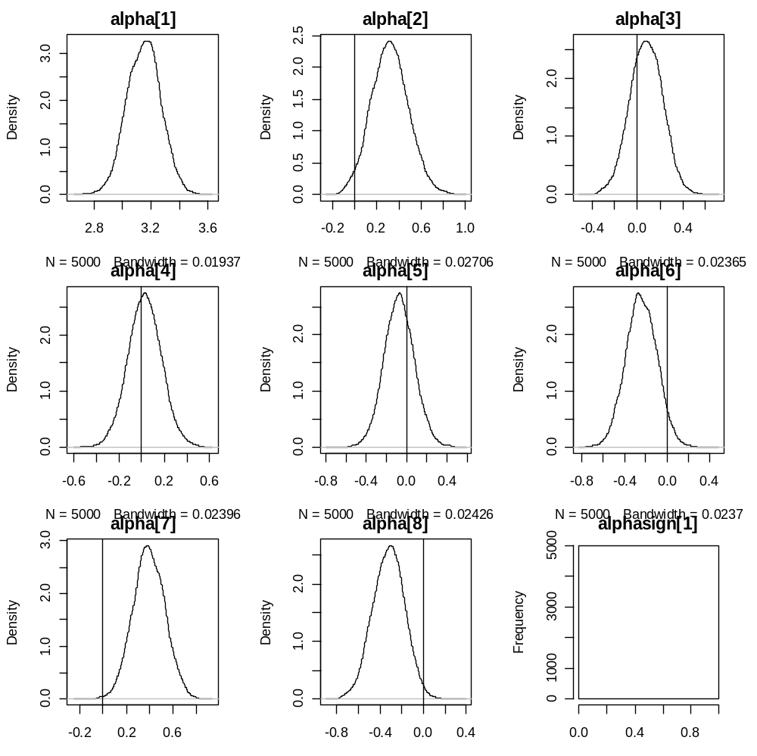

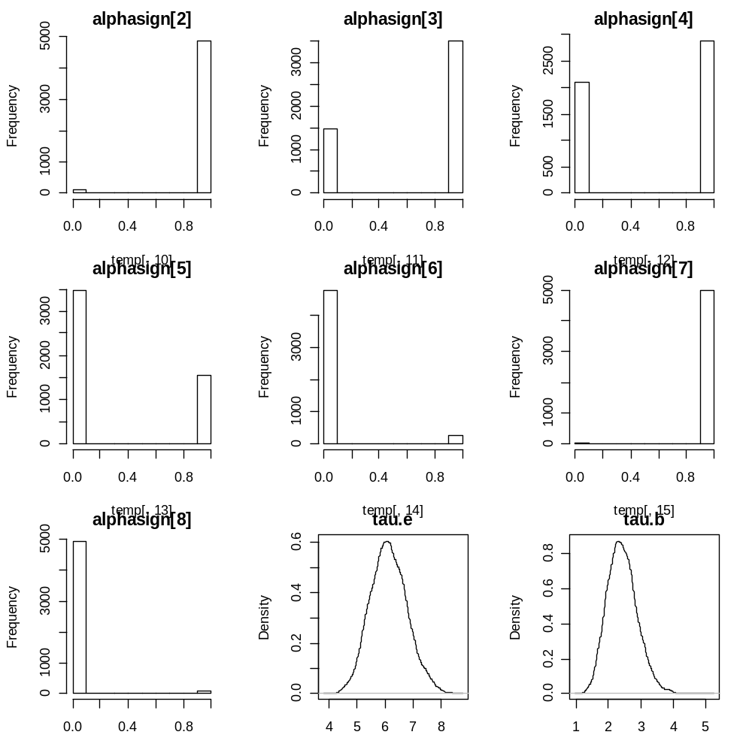
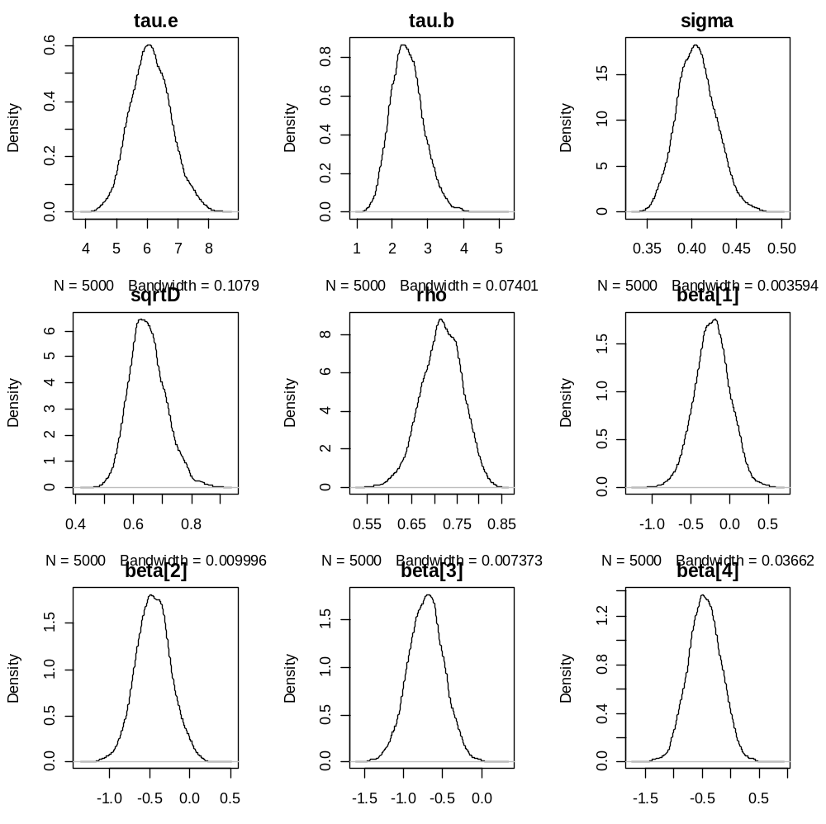
General conclusion: Need to use a slightly larger bandwidth in calculating the density estimates, and/or longer run (ie more iterations.)
These next plots are special – these are the predictions for the two missing observations. The first two are the predictions on the logged scale, and the second two back-transform to the original scale in seconds.
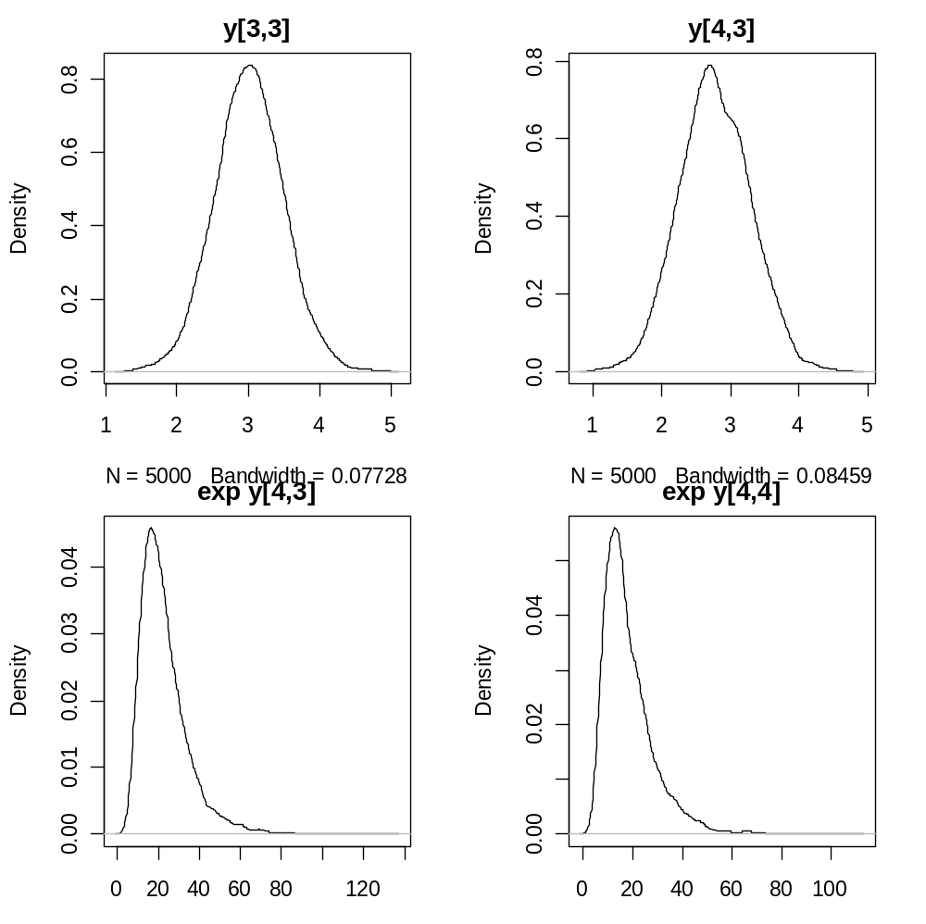

Autocorrelation Plots

I always look at all the autocorrelation plots for my parameters at least once, until I get a feel for how the model works. After I understand the model, then I will pick out the “worst” parameters, those with the worst autocorrelation functions and plot those for each run. First we need to figure out which parameters have the worst autocorrelation functions.

Fixed Effects alpha

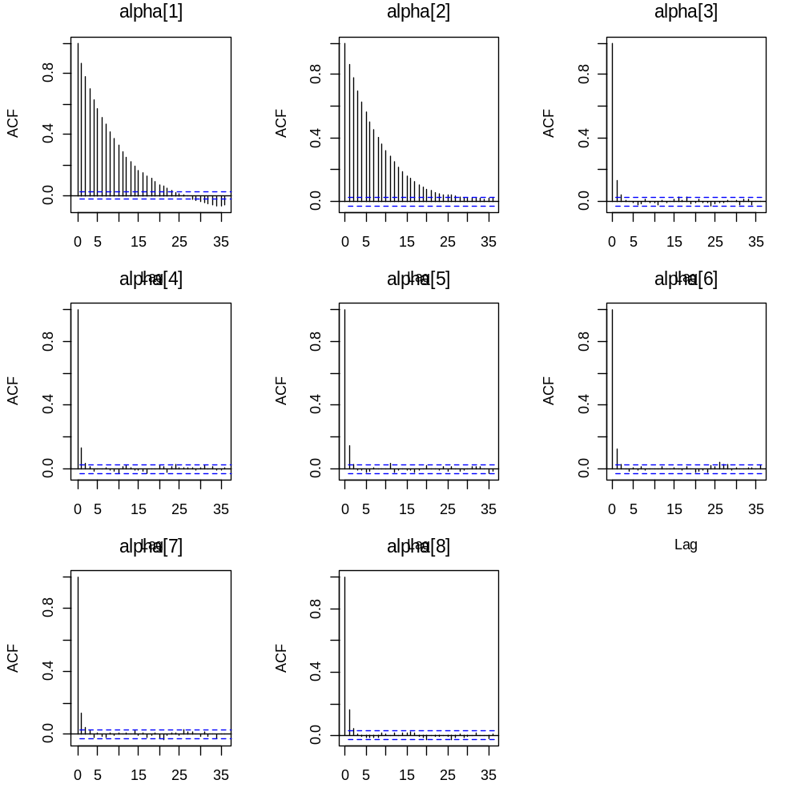

The intercepts are the worst of parameters. Typical command to plot these:
acf(temp2[,1,3], main="")
mtext("alpha[3]",side=3, line=1, cex=.8)

Here is the same with longer lags’ autocorrelations plotted as well.
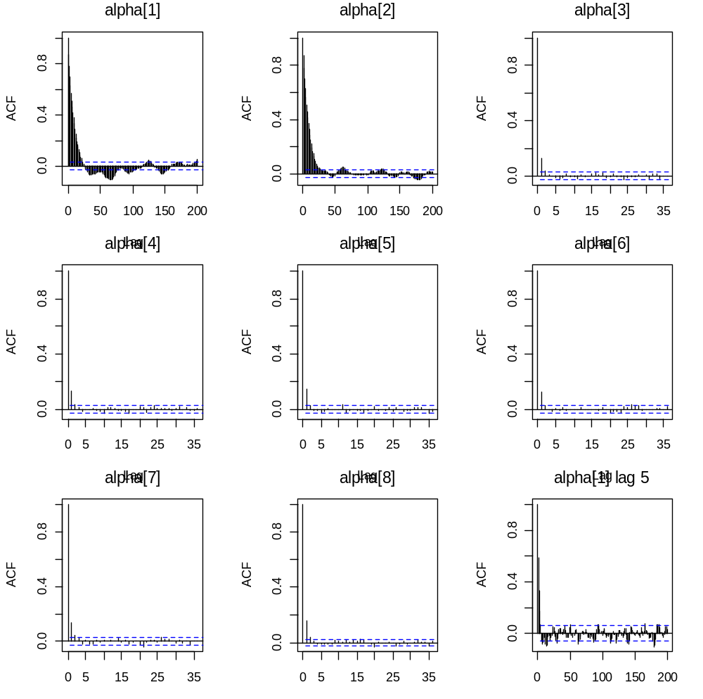
The intercepts still have some autocorrelation going on at high lag values! The last calculation takes a lag of 5 and goes out to a lag of 200*5. It looks like the autocorrelations go zero back at the earlier lag of around 25 or so. Commands:
acf(temp2[,1,1], main="", lag.max=200) # first plot
mtext("alpha[1]",side=3, line=1, cex=.8)
acf(temp2[1:1000*5,1,1], main="", lag.max=200) #last plot with lag 5
mtext("alpha[1] lag 5",side=3, line=1, cex=.8)
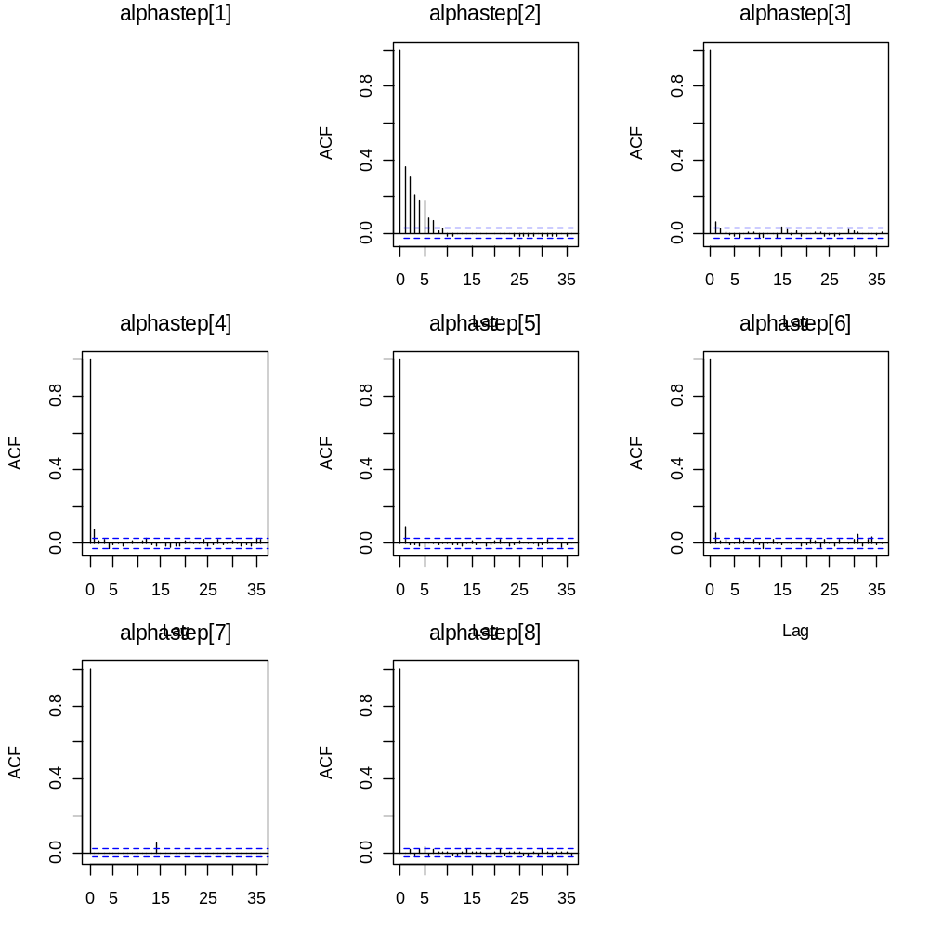
There is an error in calculating the autocorrelation function for alphastep[1]. Why?
Other alphastep parameters seem ok.
Rough rule of thumb: take the parameter with the worst autocorrelation, find the lag where the autocorrelation settles down to zero, and multiply by 1000. That’s the minimum number of samples needed for good inference. In this example, alpha[1] looks like the worst parameter, and we should shoot for 35*1000=35000 to 200*1000 = 200000 iterations.
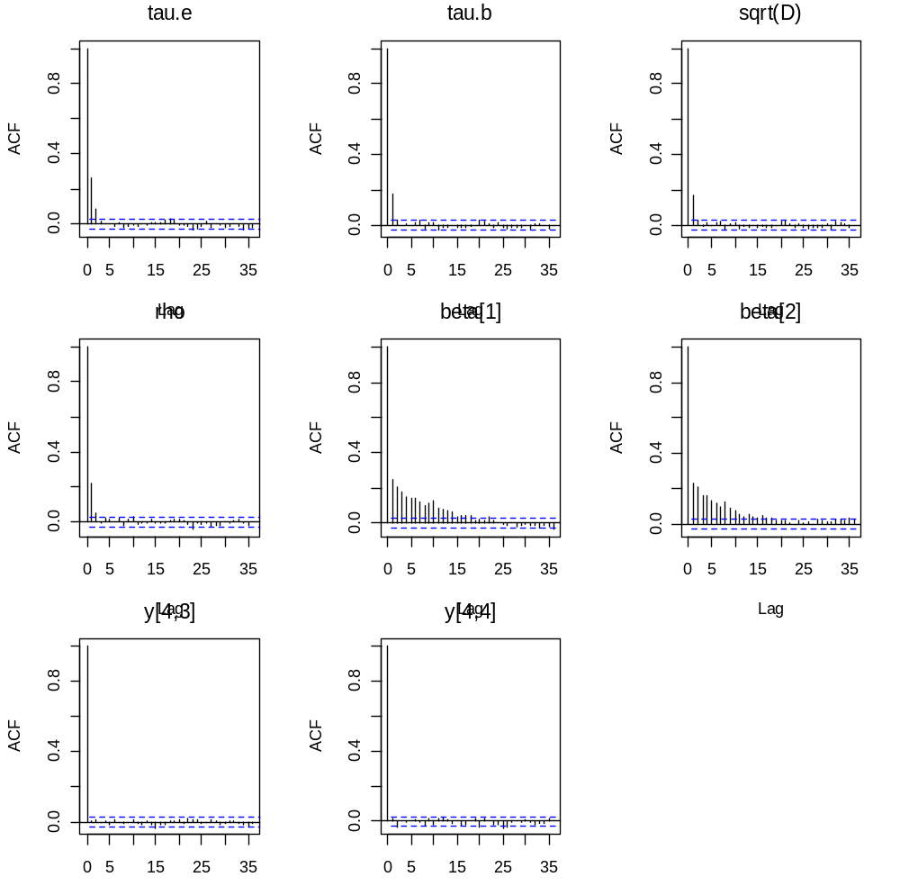
Predictions rarely cause autocorrelation problems. The random effects aren’t too bad. Usually random effects aren’t too bad. The precision/variance of the random effects is often among the worst behaving of parameters.

Scatterplot matrix of selected parameters.
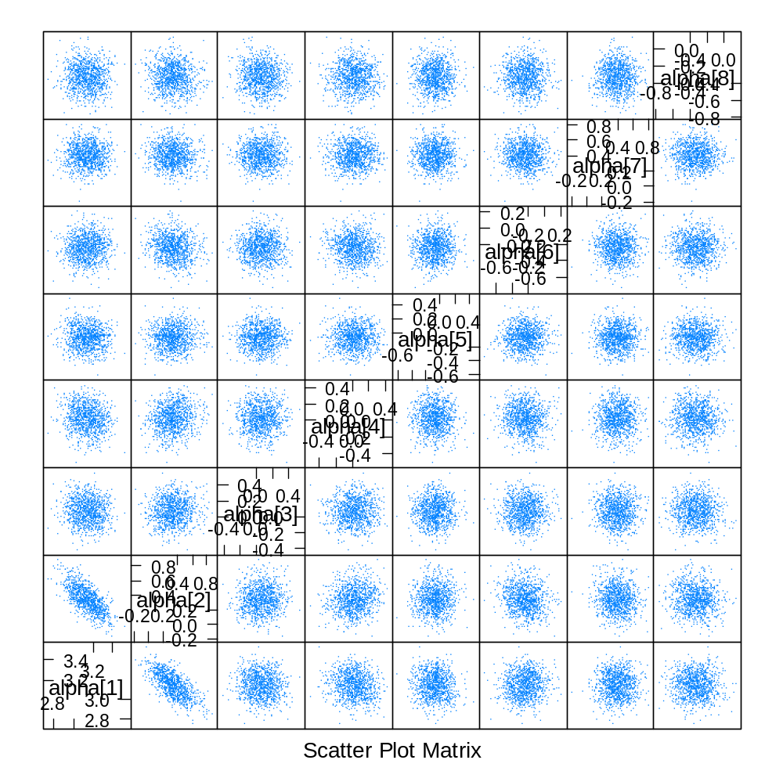
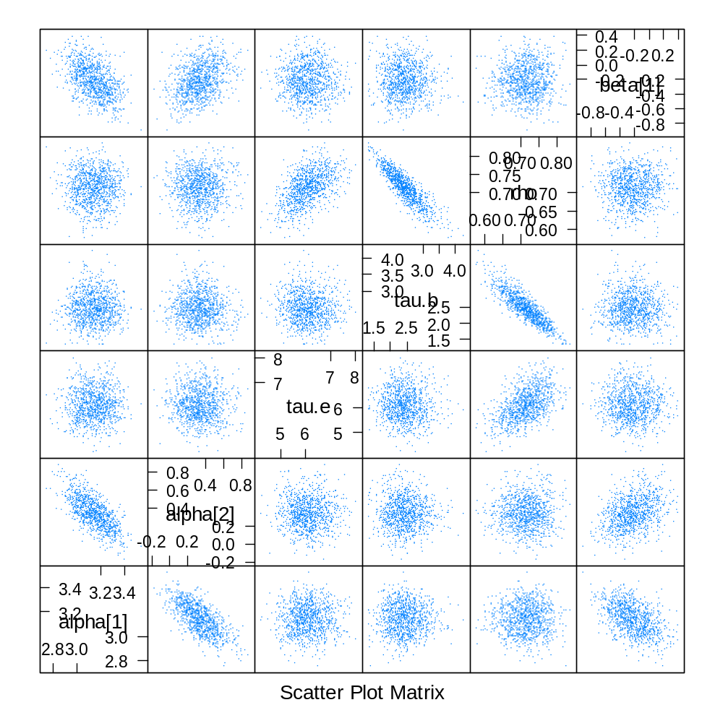
Looking for nonlinear relationships, high colinearity. If two parameters are collinear, a simple linear transformation will often greatly improve the computational algorithm.

Time Series Plots

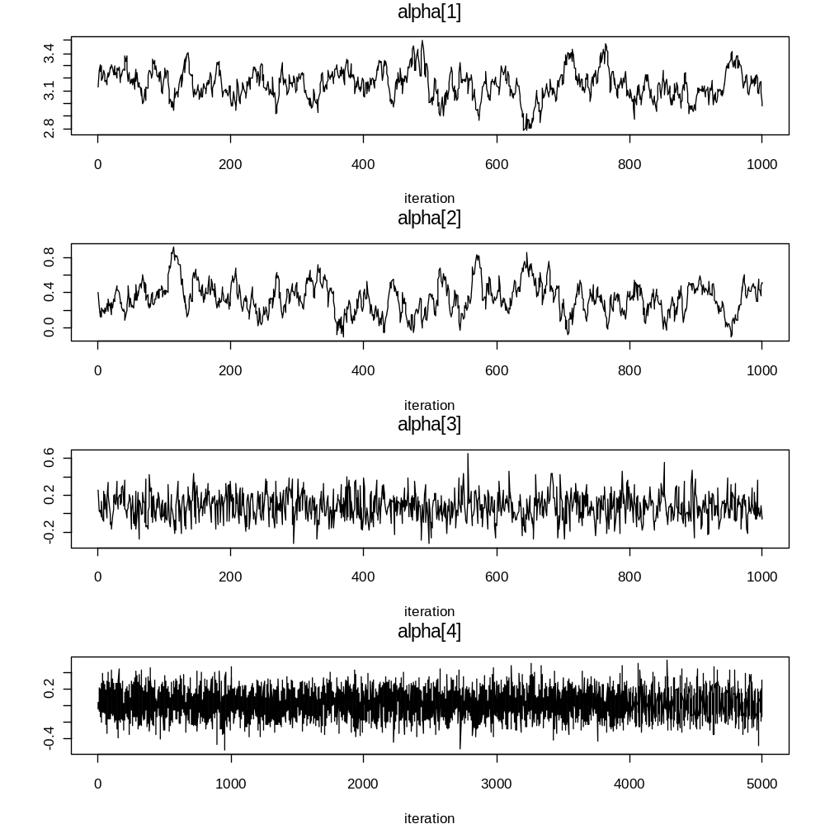
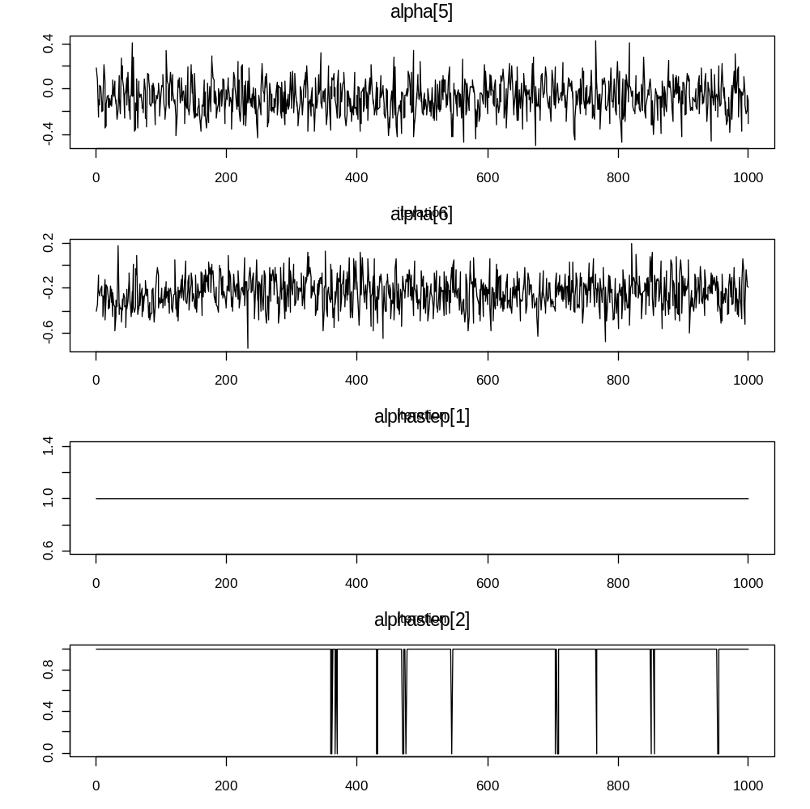
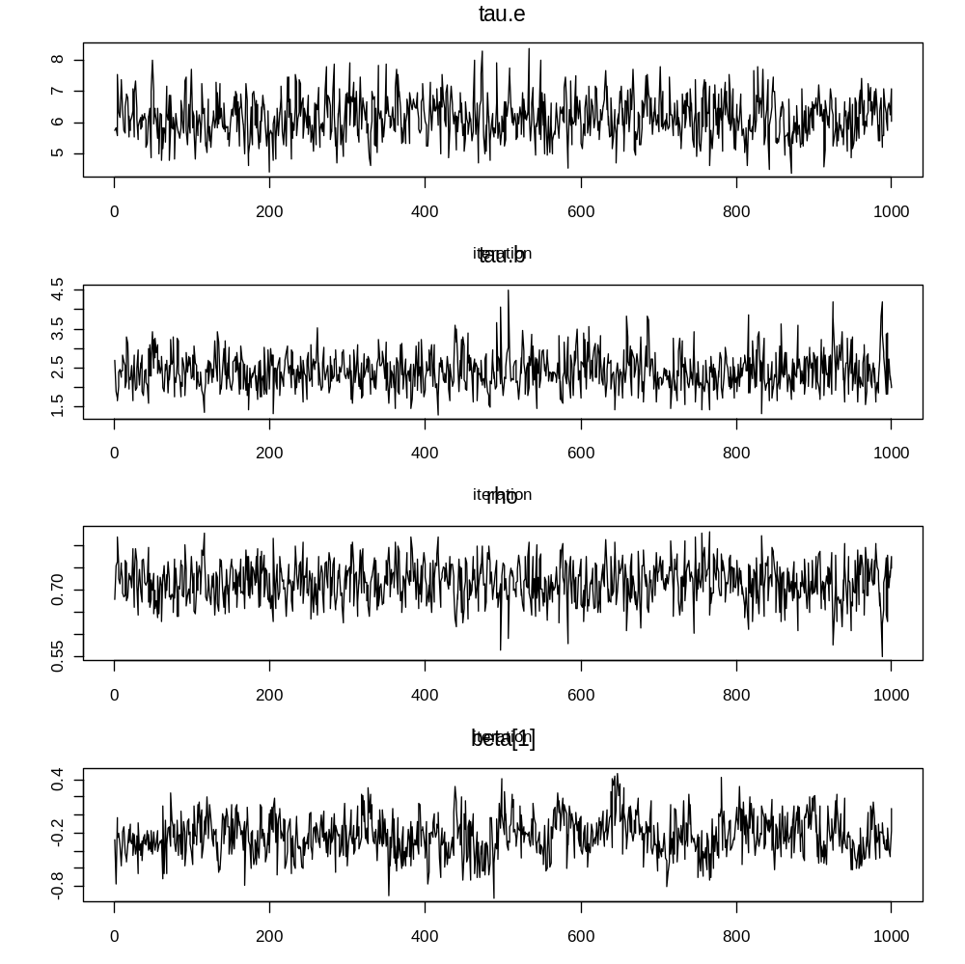
Time series plots confirm the results of the autocorrelation plots. We need in the neighborhood of 25,000 to 100,000 iterations.

Inferences of Interest

Posterior Summary Tables

2.5% 97.5%
alpha[1] 3.15 0.12 2.92 3.38 1.00
alpha[2] 0.32 0.17 0.01 0.66 0.98
alpha[3] 0.08 0.14 -0.21 0.36 0.70
alpha[4] 0.03 0.15 -0.26 0.32 0.58
alpha[5] -0.07 0.15 -0.36 0.22 0.31
alpha[6] -0.24 0.14 -0.52 0.05 0.05
alpha[7] 0.39 0.14 0.12 0.67 1.00
alpha[8] -0.32 0.15 -0.61 -0.04 0.01
alphasign[1] 1.00 0.00 1.00 1.00 1.00
alphasign[2] 0.98 0.15 1.00 1.00 0.98
alphasign[3] 0.70 0.46 0.00 1.00 0.70
alphasign[4] 0.58 0.49 0.00 1.00 0.58
alphasign[5] 0.31 0.46 0.00 1.00 0.31
alphasign[6] 0.05 0.21 0.00 1.00 0.05
alphasign[7] 1.00 0.06 1.00 1.00 1.00
alphasign[8] 0.01 0.12 0.00 0.00 0.01
tau.e 6.13 0.66 4.92 7.52 1.00
tau.b 2.43 0.46 1.63 3.42 1.00
sigma 0.41 0.02 0.36 0.45 1.00
sqrtD 0.65 0.06 0.54 0.78 1.00
rho 0.72 0.04 0.62 0.80 1.00
beta[1] -0.22 0.23 -0.67 0.22 0.17
beta[2] -0.45 0.22 -0.87 -0.01 0.02
beta[3] -0.71 0.23 -1.16 -0.27 0.00
beta[4] -0.45 0.29 -1.01 0.10 0.06
beta[5] 0.13 0.22 -0.30 0.57 0.72
y[4,3] 3.01 0.48 2.07 3.97 1.00
y[4,4] 2.78 0.52 1.79 3.79 1.00
deviance 253.82 13.98 229.20 283.90 1.00

Here is a better formatted output, taken from excel.

 |  | Mean | SD | 2.50% | 97.50% | P(Β>0|Y)
Baseline: | Intercept | 3.15 | .12 | 2.92 | 3.38 | 1.00
 | Distract- Attend | .32 | .17 | .01 | .66 | .98
Treatment effects: | AA | .08 | .14 | -.21 | .36 | .70
 | AD | .03 | .15 | -.26 | .32 | .58
 | AN | -.07 | .15 | -.36 | .22 | .31
 | DA | -.24 | .14 | -.52 | .05 | .05
 | DD | .39 | .14 | .12 | .67 | 1.00
 | DN | -.32 | .15 | -.61 | -.04 | .01
 | tau.e | 6.13 | .66 | 4.92 | 7.52
 | tau.b | 2.43 | .46 | 1.63 | 3.42
 | sigma | .41 | .02 | .36 | .45
 | sqrtD | .65 | .06 | .54 | .78
 | rho | .72 | .04 | .62 | .80
 | beta[1] | -.22 | .23 | -.67 | .22 | .17
 | beta[2] | -.45 | .22 | -.87 | -.01 | .02
 | beta[3] | -.71 | .23 | -1.16 | -.27 | .00
 | beta[4] | -.45 | .29 | -1.01 | .10 | .06
 | beta[5] | .13 | .22 | -.30 | .57 | .72
 | y[4,3] | 3.01 | .48 | 2.07 | 3.97
 | y[4,4] | 2.78 | .52 | 1.79 | 3.79
 |  | exponential
Predictions for missing | y[4,3] | 20.3 |  | 7.9 | 53.0
data on the unlogged | y[4,4] | 16.1 |  | 6.0 | 44.3
scale.

The six AA AD AN DA DD DN effects are the effect of the treatment, given by the second letter A/D/N on members of the attend or distract group, given by the first letter A/D.

Conclusions:
- At baseline, distracters have a greater pain tolerance than attenders since the probability that alpha[2] >0 is .98, alternatively, it has a one-sided p-value of .02 = 1 - .98.
- No treatment is significant for the attenders as alpha[3:5] have posterior 95% intervals that contain zero, the p-values are neither small (near zero) nor large (near one).
- The attend and null treatment actually made the distractors response times WORSE. We expected this for the attend treatment but not for the null. The distract treatment helped the kids better tolerate the pain: alpha[7] had a posterior mean of .39 with a posterior standard deviation of only .14.
- We included a few of the random effects as parameters to estimate. We can get a look at these five. They show us how poorly estimated each kid’s random effect is estimated, with standard deviations around .22 and for the kid with only 2 observations (subject 4), the standard errors are even higher. The beta’s are usually not too interesting unless we have interest in a specific kid.
- rho is around .7, indicating fairly strong correlation between repeated measures within kid. In some analyses, this parameter is of primary inference, for example in agricultural examples.
- sigma, sqrtD, and tau.b and tau.e are harder to interpret unless we are able to transform them back to the original scale. The meaning of sqrtD is that
alpha[1] +/- 2*sqrtD
is a 95% interval for the kid’s average baseline values for attenders, and
alpha[1] + alpha[2] +/- 2*sqrtD
is a 95% interval for distractors.
- The y[] values are given to show that BUGS, and Bayesian inference in general give predictions as a natural part of the analysis. These missing data values are treated EXACTLY like parameters; they have distributions, we can estimate them and make predictions for them. If we were interested in predictions for particular treatment effects, or particular covariate values, we would pay close attention to the y results.
- The exponentiated results on the last two lines. These are exactly 20.3 = exp(3.01) and 7.9 = exp(2.07). These say that a 95% prediction interval for the missing fourth observation for subject #4 is 6.0 seconds to 44.3 seconds.

Posteriors

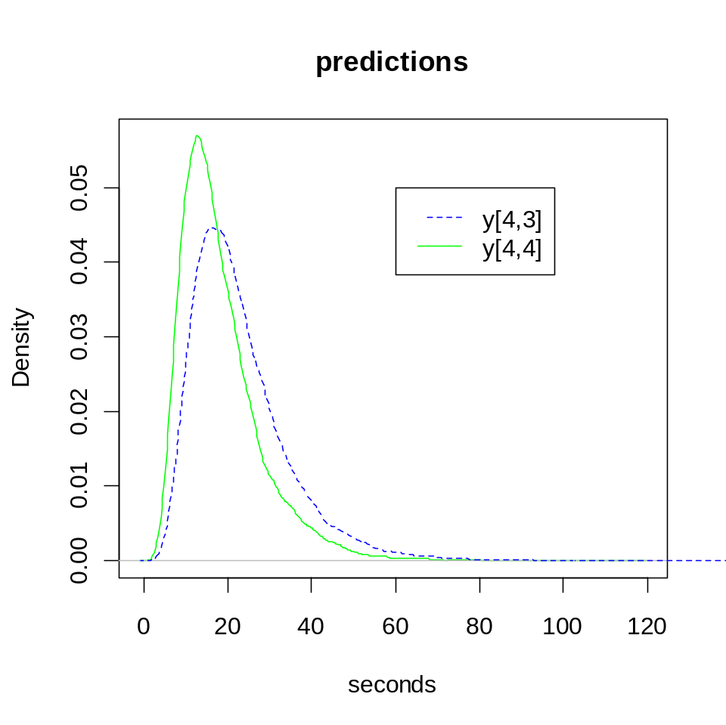
Predictions for two missing cases, subject 4 observations 3 and 4.
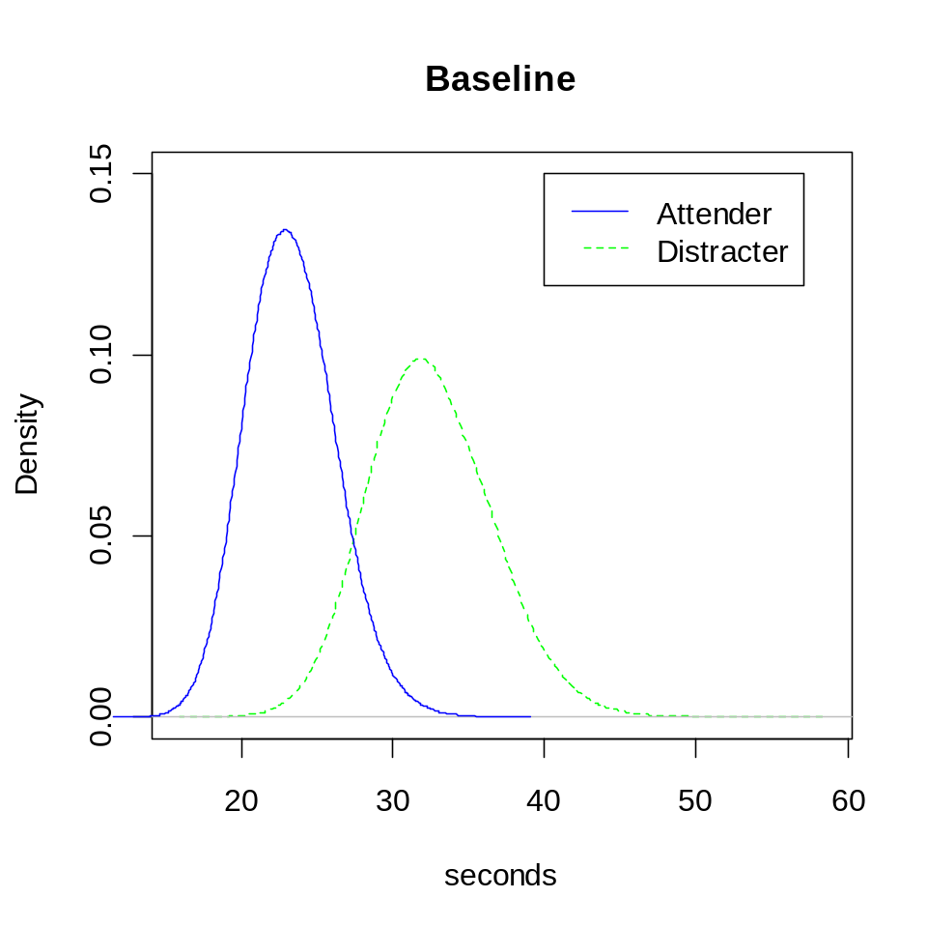
Median group times at baseline.
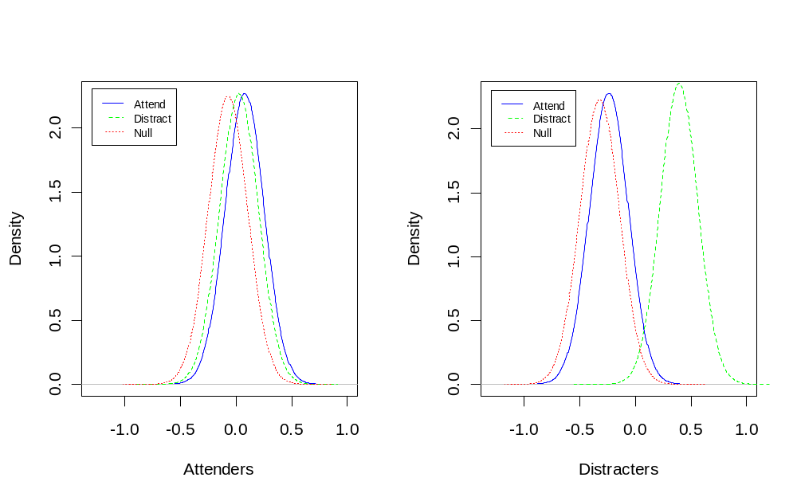
Attender and distracter treatment effects.
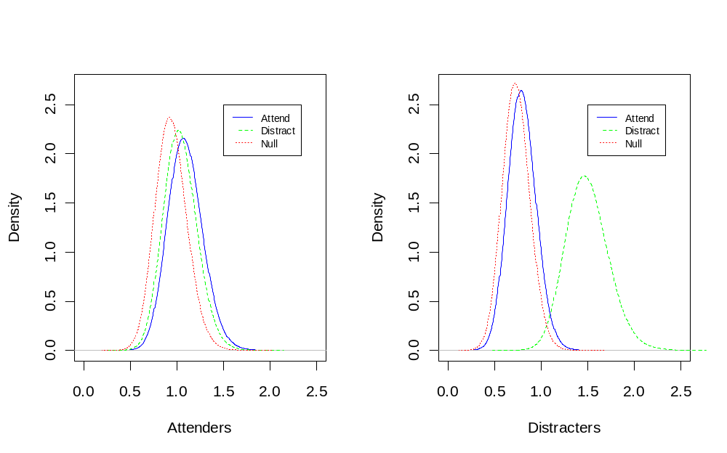
Multiplicative effects.
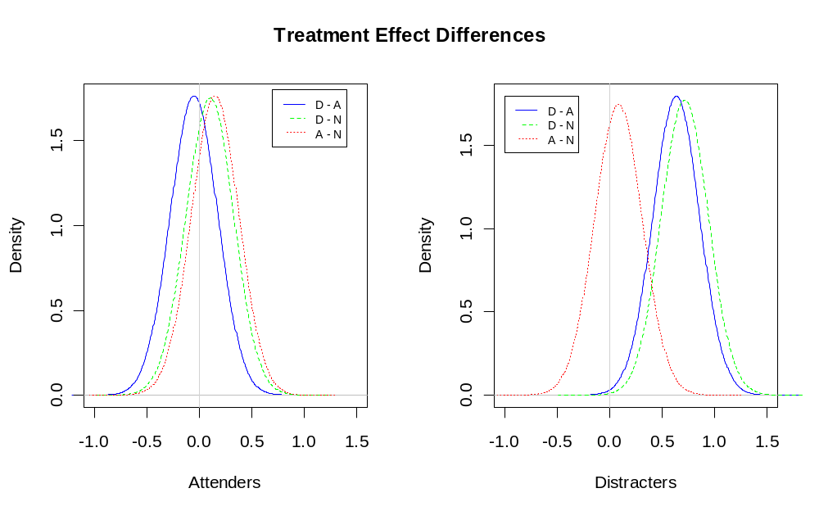
Treatment effect differences. No differences among attenders. Distract treatment is significantly better than other treatments for distracters.

Code to draw this last plot

X11(8,5) ## opens a window that is 8in wide and 5in high
par(mfrow=c(1,2)) ## says to draw two plots next to each other.

plot(density(temp[,4] - temp[,3], bw=.1), main="",
xlab="Attenders", ylab="Density", col="blue",
lty=1, xlim=c(-1.,1.5) )
# The difference of the two treatment effects alpha[4] and alpha[3]
# is the transformation of the parameters that we are interested in

# labels for the xaxis (xlab), yaxis (ylab),
# xlim gives range for the x axis. Chosen to make both plots
# have the same x and y axis ranges.

# Choice of densities, labels, xlims, location for the legend
# require iterative calculation and rearrangement until the
# plot looks ok.
# Most plots take 10-20 intermediate plots until they look good.

lines(density(temp[,4] - temp[,5], bw=.1), lty=2, col="green")
lines(density(temp[,3] - temp[,5], bw=.1), lty=3, col="red")
legend(.7, 1.8, c("D - A", "D - N", "D - A"), lty=c(1,2,3),
col=c( "blue", "green", "red"), cex=.7)
abline(v=0, col="lightgrey")
# Draw a line at x=0 to indicate the boundary between positive
# and negative effects.

plot(density(temp[,7] - temp[,6], bw=.1), main="",
xlab="Distracters", ylab="Density", col="blue",
lty=1, xlim=c(-1,1.5) )
lines(density(temp[,7] - temp[,8], bw=.1), lty=2, col="green")
lines(density(temp[,6] - temp[,8], bw=.1), lty=3, col="red")
legend(-1, 1.8, c("D - A", "D - N", "D - A"), lty=c(1,2,3),
col=c( "blue", "green", "red"), cex=.7)
abline(v=0, col="lightgrey")
title("Treatment Effect Differences", outer=T, line=-2)

